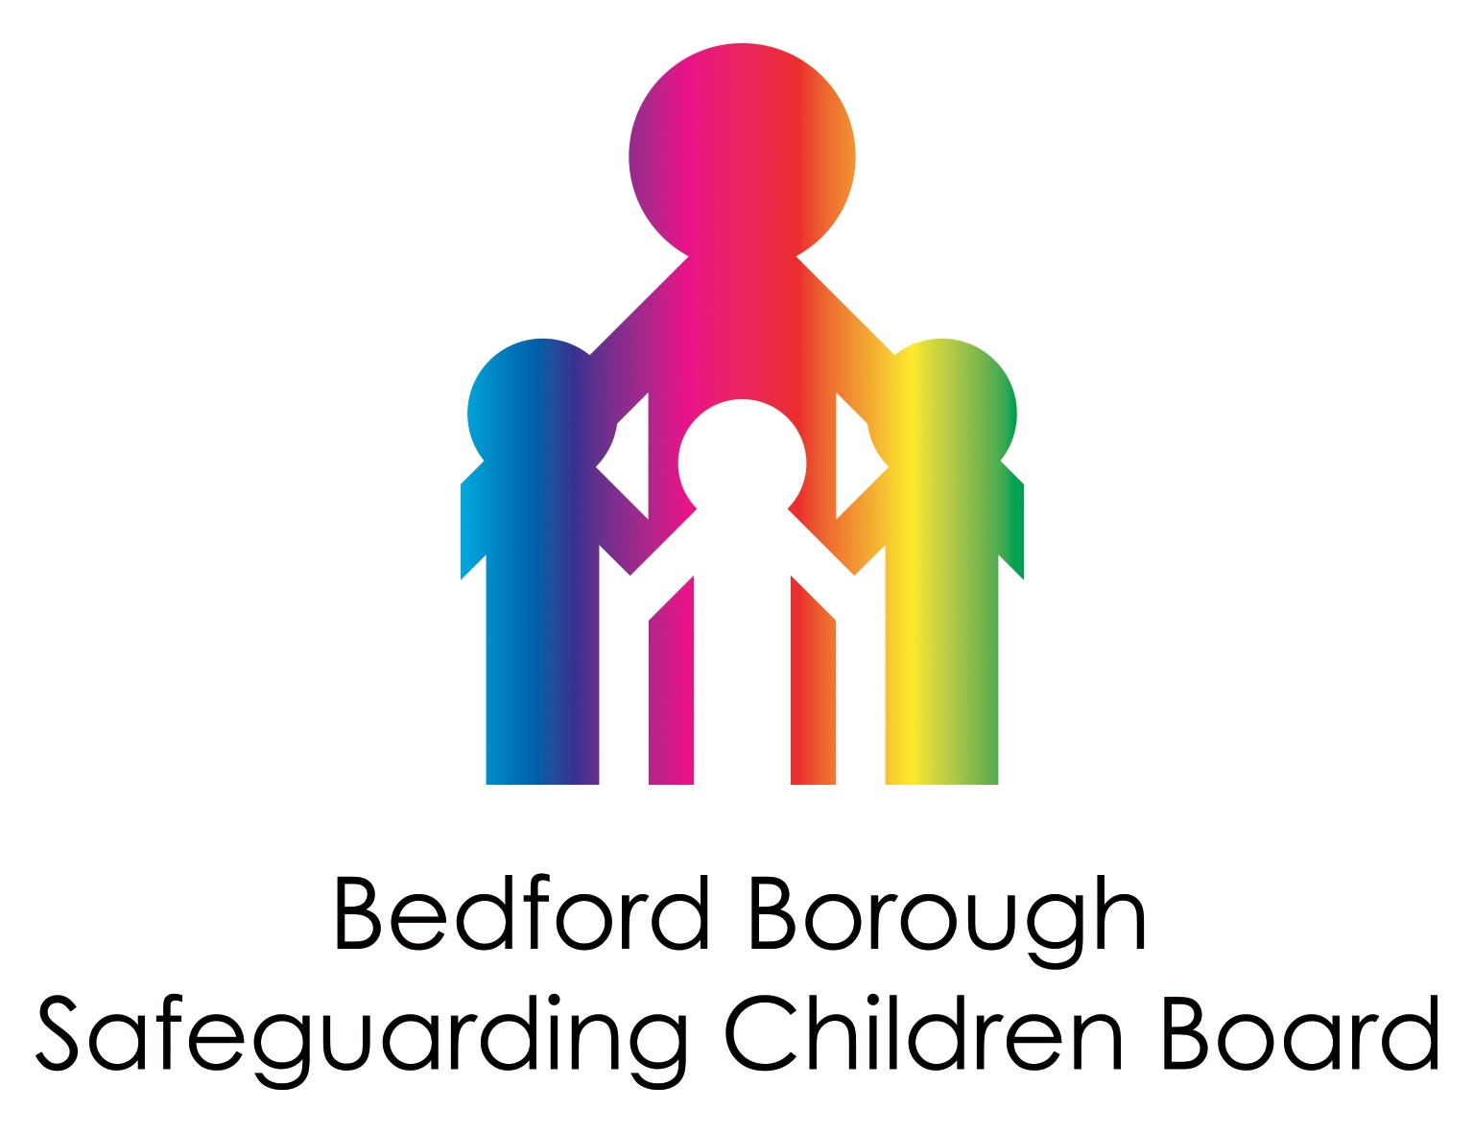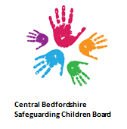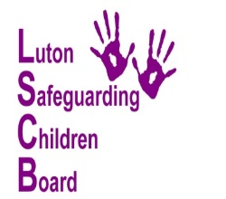

Notification of a Serious Incident
for consideration for a Local Child
Safeguarding Practice Review or
NON-Serious Incident Notification which may have multi-agency learning

Child/children’s initial/s:

Date of referral

Serious Incident Notification | Yes or No (delete as appropriate)
NON-Serious Incident Notification | Yes or No (delete as appropriate)
Date of initial case discussion

Date/s of further discussions

This form consists of the following sections:

Criteria for referring cases to BBSCB, CBSCB and LSCB Page 3

Section 1 – To be completed by the referring officer Page 4 - 7

Section 2 – To be completed by agencies other than the referring agency Page 8

Section 3 – To be completed by the Case Review Group Page 8 - 10

Section 4 – To be completed by the Chair of BBSCB, CBSCB or LSCB Page 11

CRITERIA FOR REFERRING CASES TO EITHER
BEDFORD BOROUGH SAFEGUARDING CHILDREN BOARD (BBSCB), CENTRAL BEDFORDSHIRE SAFEGUARDING CHILDREN BOARD (CBSCB) OR LUTON SAFEGUARDING CHILDREN BOARD (LSCB)

Serious child safeguarding cases are those in which:

- Abuse or neglect of a child is known or suspected; and
- The child has died or been seriously harmed.

Serious harm includes (but is not limited to) serious and/or long-term impairment of a child's mental health or intellectual, emotional, social or behavioural development. It should also cover impairment of physical health. This is not an exhaustive list. When making decisions, judgment should be exercised in cases where the impairment is likely to be long-term, even if this is not immediately certain. Even if a child recovers, including from a one-off incident, serious harm may still have occurred.

The criteria which the local safeguarding partners must take into account when determining whether to carry out a Local Child Safeguarding Practice Review (LCSPR) includes whether the case highlights or may highlight:

- Improvements needed to safeguard and promote the welfare of children, including where those improvements have been previously identified;
- Recurrent themes in the safeguarding and promotion of the welfare of children;
- Concerns regarding two or more organisations or agencies failing to work together effectively to safeguard and promote the welfare of children;
- Or is a case which the Child Safeguarding Practice Review Panel have considered and concluded a local review may be more appropriate.
- Safeguarding partners should also have regard to the following circumstances:
- Where they have cause for concern about the actions of a single agency;
- There has been no agency involvement with the child / family prior to the incident and this causes for concern;
- More than one local authority, police force area or Integrated Care Board is involved, including in cases where families have moved around;
- The case may raise issues relating to safeguarding or promoting the welfare of children in institutional settings (this includes children's homes (including secure children's homes) and other settings with residential provision for children; custodial settings where a child is held, including police custody, young offender institutions and secure training centres; and all settings where detention of a child takes place, including under the Mental Health Act 1983 or the Mental Capacity Act 2005).

Some cases may not meet the definition of a 'serious child safeguarding case' but the case raises some learning and issues of importance to the local area, for example good practice, poor practice or where there have been 'near miss' events.

The term child is taken to mean all children and young people up to the age of 18.

The relevant Safeguarding Children Board will use this form to consider whether there is a need for a LCSPR. Even if the criteria is met you do not have to do one if you feel there is no new learning following the Rapid Review process. However, if you do decide to do one it can only be called a LCSPR. This encompasses all types of learning under one consistent term. For example; your LSCPR may include some or none of the following:

- Single Agency Individual Management Reviews
- Small Scale Single/Multi-Agency Audit
- Practitioner focussed learning event
- Other action to promote learning and good practice

Submission of this form should only be by named Safeguarding partners or the BBSCB, CBSCB or LSCB Strategic Board members or other agencies working with the child/young person where it is considered there is inter/intra- agency learning opportunity; or where there is likely to be media interest in a case.

Please complete Section 1 only. The objective of this section is to provide as much information that is known at the time of the notification. If information is not available, then do not delay in sending in the notification as this information can be submitted at a later stage if required.

SECTION 1

1.1 Referral Details
Date of notification
Name of referrer
Agency
Address
Tel No.
E-mail

1.2 Child’s Details
Child’s First Name:
Child’s Surname:
Any Know Aliases:
Date of birth:
(DD/MM/YYYY)
Date of death (if applicable):
(DD/MM/YYYY)
Address:
Gender: |  |  |  |  |  | Male |  |  |  | Female
Ethnic origin – please tick the relevant box
(A) White |  |  | (B) Mixed |  |  |  | (C) Asian or Asian Britain
 |  | British |  | Asian and White |  |  |  |  | Indian
 |  | Irish |  | Black African and White |  |  |  |  | Pakistani
 |  | Any other White background |  | Black Caribbean and White |  |  |  |  | Bangladeshi
 |  |  |  | Any other mixed background |  |  |  |  | Chinese
 |  |  |  |  |  |  |  |  | Any other Asian background
(D) Black or Black British |  |  | (E) Other Ethnic Group |  |  |  | (F) Not declared
 | Caribbean |  |  | Please specify |  |  |  |  | Not declared
 | African
 | Any other Black background
Faith:
Disability:
Location of incident:
Carer at time of incident:

1.3 Family composition/significant others
Name | Relationship to child | DOB | Address | Legal status and/or current criminal proceedings | Ethnic origin | Is/was subject to a CP plan?  Specify category of plan.

1.4. Agencies known to be involved with the case (please add their name and contact details)
Name | Agency | Contact details | Are they still involved?

1.5. Reason for notification (more than one box may be ticked)
Abuse or neglect of a child is known or suspected; and the child has died or been seriously harmed.
There are improvements needed to safeguard and promote the welfare of children, including where those improvements have been previously identified.
There are recurrent themes in the safeguarding and promotion of the welfare of children.
There are concerns regarding two or more organisations or agencies failing to work together effectively to safeguard and promote the welfare of children.
There is cause for concern about the actions of a single agency
There has been no agency involvement with the child/family prior to the incident and this is a cause for concern.
More than one local authority, police force area or Integrated Care Board is involved, including in cases where families have moved around.
The case may raise issues relating to safeguarding or promoting the welfare of children in institutional settings (this includes children's homes (including secure children's homes) and other settings with residential provision for children; custodial settings where a child is held, including police custody, young offender institutions and secure training centres; and all settings where detention of a child takes place, including under the Mental Health Act 1983.
The case suggests that BBSCB, CBSCB or LSCB may need to change its local protocols or procedures, or that protocols and procedures are not being adequately promulgated, understood or acted on.
There are indications that the circumstances of the case may have national implications for systems or processes or there are significant public interest or community issues.
The case is being dealt with where complex and organised abuse involving one or more abusers and a number of abused children.
The case may have possible learning for multi-agency Partners
Other reason (please specify):

1.6 Characteristics of Case
Domestic abuse |  | Alcohol abuse |  | Drug abuse
Parental mental health |  | Fabricated illness |  | Shaken baby syndrome
Sexual abuse |  | Parent in care |  | More than one child abused
Child of teenage pregnancy |  | Parent is care leaver |  | Serious illness
Emotional abuse |  | Recent neglect |  | Long standing neglect
Exploitation (CSE/CCE) |  | Missing |  | Forced Marriage
Modern Day Slavery |  | Human Trafficking |  | Female Genital Mutilation
Honour Based Abuse |  | Child on Child abuse |  | Radicalisation
Physical abuse |  | Other features (please specify)

Is the child subject to: | Yes |  | No |  | Has been |  | Don’t know
Child Protection Plan?
CIN
TAC/TAF
LAC
SEND/EHCP

Are any siblings subject to a child protection plan? | Yes | No | Has been | Don’t know
Have criminal proceedings been instigated | Yes | No |  | Possible
Has there been a conviction | Yes | No |  | Don’t know

1.7 Summary of events
Please outline events and circumstances which triggered this referral: Refer to Chapter 4 of Working Together to Safeguard Children (published July 2018), page 3 of this form and the Child Safeguarding Practice Panel: practice guidance (Set 2022). These will help to establish if the level of harm to the child is serious (life threatening or long term injury) and neglect or abuse is a contributing factor. Some incidents are not straight forward and a judgement about seriousness might need to be made.

(Please continue on a separate sheet if necessary)
1.8 Chronology of key dates
Please use the chronology for outlining key events which will help to establish whether the case meets the Local Child Safeguarding Practice Review criteria. This should include key events but does not need to be a detailed chronology at this stage.

Date of event  DD/MM/YYYY | Source of information | Description of event

NB Agencies are reminded of the need to secure their files as soon as they become aware that a Local Child Safeguarding Practice Review might take place.

Please return to the completed form to the relevant Safeguarding Children Board Business Manager:

If you are sending from police, NHS.net (email), probation then you can send without any additional security. All other organisations should password protect the referral

Bedford Borough Safeguarding Children Board
LSCB@bedford.gov.uk

Central Bedfordshire Safeguarding Children Board
cbscb@centralbedfordshire.gov.uk

Luton Safeguarding Children Board
Lutonlscb@luton.gov.uk

SECTION 2 (to be completed by agencies other than the referring agency)
2.1 Please outline events and circumstances which triggered this referral:
Refer to Chapter 4 of Working Together to Safeguard Children (published July 2018), page 3 of this form and the Child Safeguarding Practice Panel: practice guidance (Sept 2022). These will help to establish if the level of harm to the child is serious (life threatening or long term injury) and neglect or abuse is a contributing factor. Some incidents are not straight forward and a judgement about seriousness might need to be made.

(Please continue on a separate sheet if necessary)

2.2 Your details
Name |  | Agency
Address |  | Tel No:
Email
Date
Signed

Section 3 (to be completed by the relevant Safeguarding Children Board Case Review Group) - The objective of this section of the form is to determine whether the relevant Safeguarding Children Board should consider undertaking a Local Child Safeguarding Practice Review.

3.1 Details of Panel

Date of Case Review Group |  |  |  | Chair of Case Review Group:
Members of Case Review Group present – please list  Name |  |  |  | Agency
Case discussion: details of case discussion at panel meeting
Decision/recommendation
Was the Case Review Group meeting quorate? |  | Yes |  |  | No
Comments:

Was the recommendation unanimous? |  | Yes |  |  | No
Comments/reasons for dissent/who?

Was the criteria met? (Please tick all that apply) |  | Abuse or neglect of a child is known or suspected; and either
 |  | The child has died
The child has been seriously harmed.

Serious harm includes (but is not limited to) serious and/or long-term impairment of a child's mental health or intellectual, emotional, social or behavioural development. It should also cover impairment of physical health. This is not an exhaustive list. When making decisions, judgment should be exercised in cases where the impairment is likely to be long-term, even if this is not immediately certain.

1) It was agreed that this case: (Please tick the relevant box)

Meets the threshold (Criteria) for a Local Child Safeguarding Practice Review.
Meets the threshold (Criteria) for a Local Child Safeguarding Practice Review however the Rapid Review process has already identified all the learning in the case already.
The case may raise issues which are complex or of national importance such that a National Review may be appropriate.
Does not meet the threshold (Criteria) for a Local Child Safeguarding Practice Review

2. Reasons (include brief analysis of how decision reached)

3. Any immediate practice improvements to be made as a result of the Rapid Review?

4. Was the incident notified to National Panel?

Yes
No

5. Decision fed back to the referring agency?

Yes
No
By whom
Date

SECTION 4 (to be completed by the Independent Chair/Scrutineer of the relevant Safeguarding Children Board)

The decision in section 3 was discussed by the Case Review Group on the …………… and the following has been recommended.

4.1 Decision
My decision is that a Local Child Safeguarding Practice Review:
- Should take place for the following reasons:

Any recommendations for methodology and purpose for LCSPR if one is being commissioned?

- Should not take place for the
following reasons:

Any recommendations for how the learning in the case will be collated and disseminated?

Name
Date
Signed

*Further Guidance on Child Practice Safeguarding Reviews can be found within the Pan Bedfordshire Child Protection Procedures.

