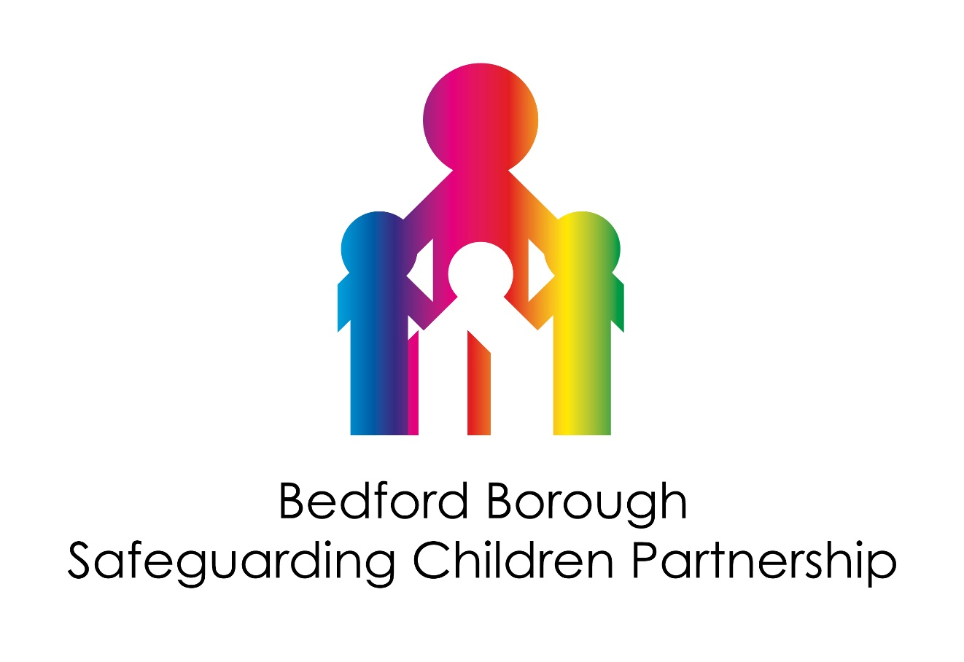

Bedford Borough
Multi-Agency Safeguarding Arrangements

September 2024

Name of Arrangements: Bedford Borough Safeguarding Children Partnership

Geographical Area covered by arrangements: Bedford Borough. These Multi-Agency Safeguarding Arrangements cover the area of Bedford Borough; however, it should be noted that where possible a lot of our work is conducted across the area of Bedfordshire in collaboration with the Central Bedfordshire and Luton Safeguarding Children Partnerships.

Local Safeguarding Partner Agencies:
- Bedford Borough Council
- Bedfordshire, Luton & Milton Keynes Integrated Care Board (BLMK ICB)
- Bedfordshire Police

Our Lead Safeguarding Partners are:
- The Chief Executive of Bedford Borough Council
- The Chief Executive of Bedfordshire, Luton & Milton Keynes Integrated Care Board (BLMK ICB)
- The Chief Constable of Bedfordshire Police

Our Delegated Safeguarding Partners are:
- The Executive Director for Children, Education & Families (DCS) and Chief Officer for Social Care and Early Help, Bedford Borough Council
- Chief Nursing Director and Deputy Chief Nurse – Bedfordshire, Luton & Milton Keynes Integrated Care Board (BLMK ICB)
- Assistant Chief Constable and Detective Chief Superintendent, Head of Crime and Public Protection. – Bedfordshire Police.

Designated Police Officers:
The multi-agency safeguarding arrangements will receive support from named Detective Superintendents and Detective Chief Inspectors as safeguarding system leaders and subject experts according to agreed terms of reference.

Designated health professionals:
Designated doctors and nurses, as senior professionals, clinical experts and strategic leaders, are a vital source of safeguarding advice and expertise for all relevant organisations and agencies. They also provide advice and support to other health practitioners across the health economy. The NHS commissioners and providers should ensure that designated professionals are given sufficient time to be fully engaged, involved and included in the new safeguarding arrangements.

Local Authority officers:
The multi-agency safeguarding arrangements will receive support from safeguarding system leaders and subject experts including the Director of Adult Services, the Service Director Children’s Operations, the Service Director for Education, Service Director for Housing, Service Director Public Health, Head of Service for Safeguarding Quality Assurance, Practice Improvement and Principal Social Worker, and Head of Service for Youth Offending Services.

Principles of the Partnership:
Strong effective multiagency safeguarding arrangements do not just happen; they demand an active commitment to collaboration and a common purpose. Effective protection of children and the promotion of their wellbeing can only be secured through working together. Safeguarding arrangements for the children and young people being built, sustained, evaluated, and continuously improved. In accordance with Working Together 2023 (para 63):

Strong leadership and clear accountability are crucial for effective multi-agency safeguarding arrangements. To strengthen accountability, local safeguarding arrangements should separate the roles of partnership chair and independent scrutiny and be clear about the three distinct functions within effective local safeguarding arrangements:

- the Partnership Chair has authority, is decisive and enables resource allocation, with risk escalation to lead safeguarding partners at the executive
- a business management function with adequate resources and capacity to support the Partnership Chair
- a rigorous and effective independent scrutiny function providing challenge to the safeguarding partners
The Partnership will be driven by the following guiding principles:

- Safeguard the rights of all children consistently across the county but not losing the focus on the needs of Bedford Borough children and young people.
- That all partners keep the child in focus when making decisions about their lives and work in partnership with them and their families.
- All partners champion a continuous cycle of learning, to further develop service provision and delivery to support the child and their family.
- Duty to co-operate on all partners, particularly schools.
- Independent challenge, authority, and resource to fulfil both statutory functions & ensure learning.
- That any change is not led by austerity or efficiencies but by measurable improvements in the safeguarding system that benefit children and families.

Governance:
The overall governance for the multi-agency safeguarding arrangements sits with the three Multi-agency Statutory Safeguarding Partners and sits within their internal governance structures.

Chairing Arrangements:
The Chair of the Bedford Borough Multi-Agency Safeguarding Arrangements will be the Director of Children’s Services for the first year and then discussions will take place to determine which DSP will take over the role. The function of the Partnership Chair is to:

- To develop strategic links, support and hold to account all LSPs in fulfilling their safeguarding duties for children.
- Ensure that local arrangements are designed to work collaboratively and effectively by encouraging and supporting the development of partnership working between the LSPs, DSPs, independent scrutiny role and MASA subgroups.
- Chair the meetings of the DSPs, including any additional meetings convened as a response to specific and exceptional circumstances, with the help of the business manager and independent scrutiny role.
- Offer appropriate challenge to ensure that the partners are accountable, and that the local arrangements operate effectively.

Reporting:
The Safeguarding Partners will produce a joint yearly report, outlining the work they have undertaken together over the previous 12-month period and will be published on the Safeguarding Bedfordshire website. The focus of the report will be in relation to what work has been undertaken in relation the multi-agency priorities and any learning, impact, evidence, and improvement. The report will also include what the Partnership have done because of any child safeguarding practice reviews.

The report should also include the following:
- The contribution of each safeguarding partner to the functioning and structure of the multi-agency safeguarding arrangements
- Any themes emanating from aggregated methods of scrutiny, for example, reviews and scrutineer activity and multi-agency audits.
- Evidence of the impact of the work of the safeguarding partners and relevant agencies, including training, on outcomes for children and families
- An analysis of any areas where there has been little or no evidence of progress on agreed priorities.
- An analysis of learning from serious incidents
- A record of key decisions and actions taken by the safeguarding partners in the yearly cycle, including in relation to implementing the recommendations from any local and national child safeguarding practice reviews and the impact this has had.
- Ways in which the safeguarding partners have sought and utilised feedback from children and families to inform their work and influence service provision.
- The breakdown of costs in delivering the arrangements for that period, including the financial contributions of individual partners, any changes to funding and an assessment of the impact and value for money of this funding
- Evidence of how safeguarding partners are ensuring the adequate representation and input of education at both the operational and strategic levels of the arrangements.
- An overview of how data is being used to encourage learning within the arrangements and evidence of how information sharing has improved practice and outcomes.
- A review of the impact and learning from independent scrutiny arrangements to ensure the leadership is strong and the arrangements are leading to the desired and necessary impact.
- Any updates to the published arrangement with the proposed timescale for implementation
- Evidence that national reforms have been implemented, taking into account key decisions and actions taken by safeguarding partners in response to reforms, and any issues or concerns encountered within the yearly cycle.

The report will be published on the Safeguarding Partnership website and a copy will also be sent to the National Child Safeguarding Practice Review Panel and the What Works Centre for Children's Social Care within 7 working days of being published.

Arrangements for Independent Scrutiny:
The Bedford Borough Multi-Agency Safeguarding Arrangements has in place an Independent Scrutineer, Sally Rowe, whose role it is to provide the following to the Partnership: (as outlined in Working Together 2023)

- Provide safeguarding partners and relevant agencies with independent, rigorous, and effective support and challenge at both a strategic and operational level.
- Provide assurance to the whole system in judging the effectiveness of the multi-agency safeguarding arrangements through a range of scrutiny methods.
- Ensure that statutory duties are being fulfilled, quality assurance mechanisms are in place, and that local child safeguarding practice reviews and national reviews are analysed, with key learning areas identified and effectively implemented across the safeguarding system.
- Ensure that the voice of children and families is considered as part of scrutiny and that this is at the heart of arrangements through direct feedback, informing policy and practice.
- Be regarded as a ‘critical friend’ and provide opportunities for two-way discussion and reflection between frontline practitioners and leaders. This will encourage and enable strong, clear, strategic leadership.
- Provide independent advice when there are disagreements between agencies and safeguarding partners and facilitate escalation procedures.
- Evaluate and contribute to multi-agency safeguarding published arrangements and the annual report, alongside feeding into the wider accountability systems such as inspections.

The Independent Scrutineer will also be responsible for chairing/overseeing the following assurance meetings:

Bedford Borough Case Review Group:
Responsible for carrying out Rapid Reviews following Serious Incident Notifications and taking forward Child Safeguarding Practice Reviews and Local Learning Reviews where appropriate. The Group also oversees the progress of implementing the relevant follow-up action plans.

Bedford Borough Performance Group:
Responsible for reviewing and scrutinising the Bedford Borough Multi-Agency Performance Framework on a quarterly basis.

Pan Bedfordshire Children’s Assurance and Improvement Group:
This role will be shared with the Independent Chair of the Central Bedfordshire and Luton Safeguarding Children Partnerships. They will be responsible for taking forward a programme of Pan Bedfordshire Multi-Agency Audits and overseeing the implementation of the learning and any actions (including the setting up of any task and finish groups as required). The group will also receive assurance through the presentation of a range of single audits and ensure that learning from audits and case reviews are transferred into the Partnership’s Multi-agency Training Offer.

The Independent Scrutineer will also be asked to complete independent deep dive audits at the request of the LSPs and DSPs in relation to themes identified by the Strategic Leads. The findings will be reported back to both the MASA and Partnership Strategic Board meetings.

A structure chart is shown below:

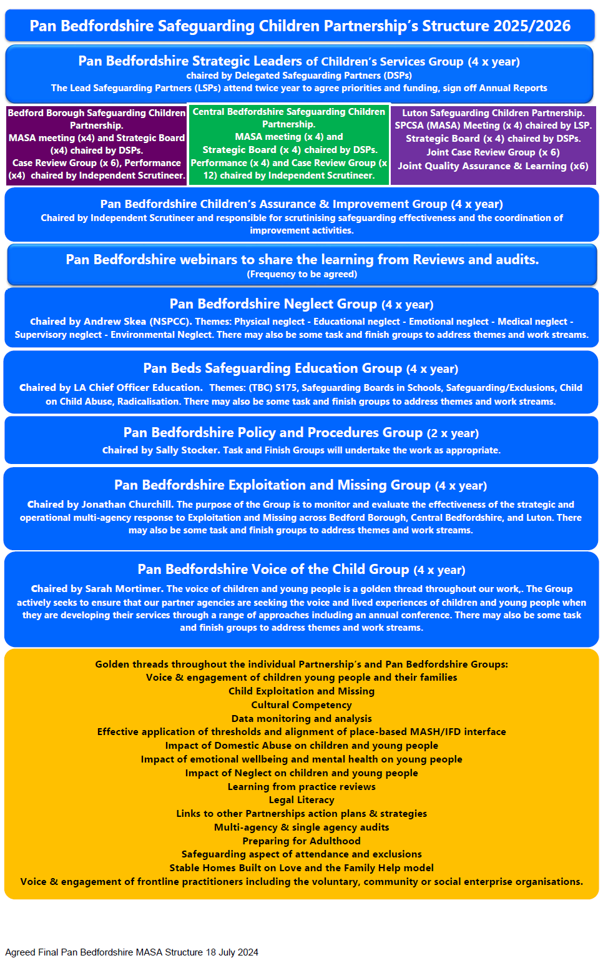
Relevant Agencies: The relevant agencies of the Bedford Borough Multi-Agency Safeguarding Arrangements are listed below. All the listed partners have a role to play in safeguarding children and young people across Bedford Borough. The Bedford Borough Safeguarding Children Partnership (BBSCP) will continue to review its relevant agencies on an annual basis as part of its annual Development Day.

- Independent Scrutineer
- Local Authority, including Adult Services, Children's Services and Public Health
- Bedfordshire Police
- Bedfordshire, Luton & Milton Keynes Integrated Care Board (BLMK ICB)
- All Education Settings including alternative provision, further education, early years and schools
- Bedfordshire Youth Offending Service
- Bedfordshire NHS Hospitals Foundation Trust
- Bedfordshire Probation Service
- East London Foundation Trust
- Cambridgeshire Community Services NHS Trust
- Representation from the Voluntary Organisations for Children, young people & families (VOCypf)
- CAFCASS (Children and Family Courts Advisory and Support Service)
- NHS England (via the ICB)
- Two lay members.

The Partnership will continue to review its relevant agencies on an annual basis as part of its annual Development Day.

How we will work together to safeguard children:
A child centered approach is fundamental to safeguarding and promoting the welfare of every child. A child centred approach means keeping the child in focus when making decisions about their lives and working in partnership with them and their families. All practitioners should follow the principles of the Children Act 1989 and 2004 that states that the welfare of the child is paramount and that they are best looked after within their families, with their parents playing a full part in their lives, unless compulsory intervention in family life is necessary.

Children may be vulnerable to neglect and abuse or exploitation from within their family and from individuals they come across in their daily lives. These threats can take a variety of different forms, including sexual, physical, and emotional abuse; neglect; exploitation by criminal gangs and organised crime groups; trafficking; online abuse; sexual exploitation and the influences of extremism leading to radicalisation. Whatever the form of abuse or neglect, practitioners should put the needs of the child first when determining what action to take.

Children are clear about what they want from effective safeguarding systems:

- Everyone who works with children has a responsibility for keeping them safe. Everyone who comes into contact with them has a role to play in identifying concerns; sharing information and taking promote action.
- In order that organisations, agencies, and practitioners collaborate effectively, it is vital that everyone works with child and families, including those who work with parents/carers, understand the role they should play and the role they should play and the role of other practitioners. They should be aware of, and comply with, this document and associated Pan Bedfordshire Child Protection Interagency Procedures.

There is no age limit on the right of the child or young person to express their views freely. All children and young people, including those of pre-school age, school age and those who have left full-time education, have a right to be heard in all matters affecting them, their views being given due weight in accordance with their age and maturity. As mentioned already, the voice and lived experiences of children and young people is a standing sub-group and golden thread running through the work of the Bedford Borough Safeguarding Partnerships and all its subgroups.

Information Sharing Principles:
The Bedford Borough Multi-Agency Safeguarding Arrangements will work together and share information based on the 7 Golden Rules of Information Sharing:

The Seven golden rules for sharing information (including personal information):
- All children have a right to be protected from abuse and neglect. Protecting a child from such harm takes priority over protecting their privacy, or the privacy rights of the person(s) failing to protect them. The UK General Data Protection Regulation (UK GDPR) and the Data Protection Act 2018 (DPA) provide a framework1 to support information sharing where practitioners have reason to believe failure to share information may result in the child being at risk of harm.

- When you have a safeguarding concern, wherever it is practicable and safe to do so, engage with the child2and/or their carer(s), and explain who you intend to share information with, what information you will be sharing and why. You are not required to inform them, if you have reason to believe that doing so may put the child at increased risk of harm (e.g., because their carer(s) may harm the child, or react violently to anyone seeking to intervene, or because the child might withhold information or withdraw from services).

- You do not need consent to share personal information about a child and/or members of their family if a child is at risk or there is a perceived risk of harm. You need a lawful basis to share information under data protection law, but when you intend to share information as part of action to safeguard a child at possible risk of harm, consent may not be an appropriate basis for sharing. It is good practice to ensure transparency about your decisions and seek to work cooperatively with a child and their carer(s) wherever possible. This means you should consider any objection the child or their carers may have to proposed information sharing, but you should consider overriding their objections if you believe sharing the information is necessary to protect the child from harm.

- Seek advice promptly whenever you are uncertain or do not fully understand how the legal framework supports information sharing in a particular case. Do not leave a child at risk of harm because you have concerns you might be criticised for sharing information. Instead, find out who in your organisation/agency can provide advice about what information to share and with whom. This may be your manager/supervisor, the designated safeguarding children professional, the data protection/information governance lead (e.g., Data Protection Officer5), Caldicott Guardian, or relevant policy or legal team. If you work for a small charity or voluntary organisation, follow the NSPCC's safeguarding guidance.

- When sharing information, ensure you and the person or agency/organisation that receives the information take steps to protect the identities of any individuals (e.g., the child, a carer, a neighbour, or a colleague) who might suffer harm if their details became known to an abuser or one of their associates.
- Only share relevant and accurate information with individuals or agencies/organisations that have a role in safeguarding the child and/or providing their family with support, and only share the information they need to support the provision of their services. Sharing information with a third party rarely requires you to share an entire record or case-file – you must only share information that is necessary, proportionate for the intended purpose, relevant, adequate, and accurate.

- Record the reasons for your information sharing decision, irrespective of whether or not you decide to share information. When another practitioner or organisation requests information from you, and you decide not to share it, be prepared to explain why you chose not to do so. Be willing to reconsider your decision if the requestor shares new information that might cause you to regard information you hold in a new light. When recording any decision, clearly set out the rationale and be prepared to explain your reasons if you are asked.

Educational Settings:
Currently on our Strategic Board we have the Chief Officer Education, SEND & School Infrastructure along with senior representatives from a local secondary school, primary schools, nurseries, and college. Our 2 Lay members come from a Private Independent School and an Alternative Education provision. Officers from the Local Authority School Improvement Team also sit on the Case Review Group, Performance Group and Pan Bedfordshire Safeguarding Education Group. This last group is chaired by the 3 Bedfordshire Local Authority Chief Officers for Education (on a rotating basis) and has representatives from schools across Bedfordshire.

The Pan Bedfordshire Safeguarding Education Group is a strategic group, tasked to bring education as the fourth safeguarding partner and reporting directly to the three Safeguarding Children Partnerships. It will ensure that the voice of the education sector within Bedfordshire is heard and represented across Bedford Borough, Central Bedfordshire, and Luton Safeguarding Children Partnership structures, building a shared understanding of priorities.

The Pan Bedfordshire Safeguarding Education Group will actively work with the three Safeguarding Children Partnerships to perform their duties in safeguarding by monitoring safeguarding activities across the county to improve outcomes for children and young people. This group provides a communication channel between education settings, including Governors, local Designated Safeguarding Lead forums and the three Safeguarding Children Partnerships. It provides support and Governance to the local cluster/ hub arrangements as they share themes, challenges, and good practice in their safeguarding work.

There is a dedicated section of the regular Schools Designated Safeguarding Leads (DSL) and Cluster Forums, where schools can raise issues or information that they would like feedback to the Pan Bedfordshire Safeguarding in Education Group. The BBSCP Business Manager will attend the DSL forum to provide updates on behalf of the Partnership, and local schools and colleges are invited to take part in audits and case reviews where relevant. The Partnership also communicates with schools via its own newsletter and a local newsletter dedicated for schools.

Early Years Settings:
The Multi-Agency Safeguarding Arrangements are currently in the process of developing their links with the Bedford Borough Early Years Forum.

Youth Custody and Residential Homes: There are no Youth Custody establishments located in Bedford Borough (or Bedfordshire) however there will at times be a number of young people from Bedford Borough who are placed in Juvenile Secure Custody across England and Wales. The manager of Bedfordshire Youth Offending Service is a member of the Bedford Borough Multi-Agency Safeguarding Arrangements. In relation to residential homes, private children's homes, and 16+ units, the Chief Officer for Children’s Services and Social Work is responsible for the Corporate Parenting/Looked After Children's Service and is a member of the Bedford Borough Multi-Agency Safeguarding Arrangements. Within Bedford Borough there are within the Bedford Borough Council Commissioning Team attend regular forums throughout the year with the local residential homes and 16+ providers which the safeguarding arrangements the BBSCP use as a link to local residential homes when needed.

Young carers:
The Partnership will request assurance reports from those services proving support to young carers in Bedford Borough.

Voice of Children and Families:
The voice of children and young people is a golden thread throughout our work, which is overseen by the Bedford Borough Voice of the Child Group. The Group actively seeks to ensure that our partner agencies are seeking the voice and lived experiences of children and young people when they are developing their services. The Voice of the Child Group also works to hear the voices of children and young people directly through activities such as the annual Pan Bedfordshire Voice of the Child Conference. Work is also underway to develop children/student Safeguarding Children Boards in Schools.

In addition:
- All Safeguarding Children Partnership reports are asked to consider the voice of the child.
- All audits consider the voice of the child(ren) and families.
- Families are always contacted to participate in local Child Safeguarding Practice Reviews and rapid reviews where appropriate.

Arrangements for disseminating and embedding Learning from Child Safeguarding Practice Reviews and Multi Agency Audits:
The Bedford Borough Multi Agency Safeguarding Arrangements has in place a Learning and Improvement Framework to help set out a process for continuously improving practice via the Continuous Learning Loop (shown below)

PRACTICE

(Sources of learning)

REVIEWS OF PRACTICE

Local Child Safeguarding Practice Reviews
Data analysis
National
learning
Planned audits.
Child death reviews

IDENTIFICATION OF LEARNING

Actions for improvement
Dissemination of learning

PRACTICE
(Embedding learning)

Learning from the above activities (LCSPRs and audits) are disseminated using a range of methods including:

- Briefings and Conferences
- Multi-Agency Training Programme
- Newsletters and briefing documents
- Via the Safeguarding Bedfordshire website
- Published LCSPRs
- Single agency training and briefings.

Link to the full Learning and Improvement Framework (under development).

Arrangements for commissioning Child Safeguarding Practice Reviews:
The following flowchart outlines the process for receiving serious incident notifications and considering/commissioning Child Safeguarding Practice Reviews.

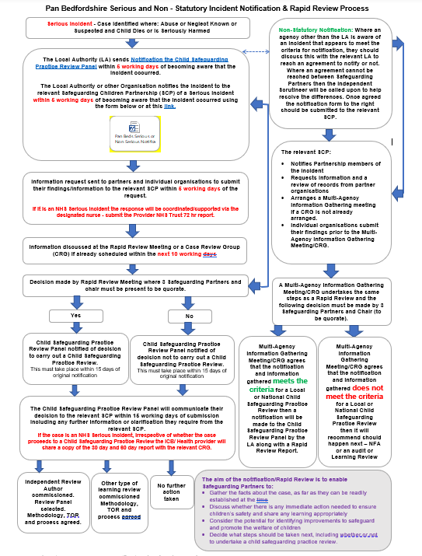

Performance Monitoring Arrangements:

Performance Monitoring and Data Analysis Arrangements:
The Bedford Borough Multi-Agency Safeguarding Arrangements will establish a multi-agency performance

framework which is monitored and scrutinised by the Bedford Borough Performance Group on a quarterly basis to understand local emerging trends and themes. Information will be reported up to the Bedford Borough Strategic Board via an update report at its quarterly meetings. In addition, performance indicators linked to themes/priority areas will also be developed by the priority area sub-groups for discussion and scrutiny within the individual sub-groups. This local analysis will further be strengthened by a Pan Bedfordshire Data Analyst (this function is currently being developed under the auspices of Luton Borough Council). The key elements of this project/post will be to:

- Develop and maintain positive relationships with colleagues, including key partners and stakeholders
across Pan Beds
- Provide specialist expertise to undertake collection and analysis of a range of information
- Create performance reports in order to ensure decision making and planning is based on a robust
- evidence base that links to the requirements for Families First for Children Pathfinder
- Implement and oversee performance management frameworks, service plans and prioritise work
- deliverables
- Manage and maintain processes, systems and procedures in accordance with governance and
- data quality guidance
- Support case selection and audit collation for Pan Beds audits
- Explore and make recommendations for data solutions to meet Pan Beds needs
- Support implementation of identified data solution ensuring sustainability of reporting
- Have an analytical eye, presenting data in different formats that tell a story and test hypothesis
- and provide recommendations. Findings to be presented at a high standard to inform
- decision making.
The Partnership performance monitoring arrangements will also aim to capture/highlight the impact our Partnership work is having on improved outcomes for our children and young people. This will be reported through our annual report process. It will be important to work closely with our Pan Bedfordshire partners to monitor the progress and impact of the Pathfinder work in our neighbouring Partnership Luton.

Training:
The Pan Bedfordshire Children’s Assurance and Improvement Group is responsible for the following in relation to training activities:

- Processes in place to identify the multi-agency training and development needs of staff and volunteers in Bedfordshire.
- Building on the current joint training and development strategy.
- Ensuring that the content of the Pan Bedfordshire Safeguarding Children Partnership training programme is based on latest research/clinical evidence about 'what works' when working with children, young people and families.
- Ensuring lessons from Child Safeguarding Practice Reviews, other reviews and audits are disseminated with a view to embed into practice.
- Overseeing the commission arrangements and ensure relevant and competent trainers are utilised with a broader range of skills.
- Monitoring and evaluating the quality and impact of training on practice development and take appropriate & timely action.

Commissioning:
External expertise is commissioned where required to ensure the quality of learning/ training. Expertise from across Bedfordshire services is also drawn upon where available to support the learning/ training programme.

Evaluation and impact of training on practice development:
Safeguarding Bedfordshire aims to provide each Partnership with a robust approach to evaluating the learning/training delivered through Safeguarding Bedfordshire, measuring both the quality of the training delivered and to evidence the impact on practice development.

Professional Practice Guidance:
All partners will continue to follow the existing Pan Bedfordshire Interagency Procedures. These will underpin the expected standardised process and practice across Bedfordshire. Adoption of these procedures will provide consistency to practitioners who are already familiar with these procedures.

Threshold Guidance:
Bedford Borough Multi-Agency Safeguarding Arrangements link to the following Threshold Guidance: Thresholds of Need Guide Effective Support for Children and Families in Bedford Borough

This guidance is designed for anyone working with children & young people and their families:
- To show the criteria for access to services for children based on a multi-agency needs/risk matrix.
- To outline the four levels of prevention, need and risk, including safeguarding thresholds.
- To set out the key principles for service provision to children, young people, and families
- To know what action to take if they are worried about a child's welfare or safety.
- To understand what will happen if a child is referred to children's social care.
- To outline the threshold between Early Help and Children's Social Care, although in some circumstances both services will be involved.

Dispute Resolution/Escalations:
Safeguarding partners will work together locally to resolve any disputes using the Pan Bedfordshire Escalation Process. The local safeguarding partners will also be able to discuss and resolve local disputes through the Pan Bedfordshire Strategic Leaders of Children's Services Group.

If the Bedford Borough Safeguarding Children's Partnership receives any complaints that fall outside of the Pan Bedfordshire 'Complaints arising from Child Protection Conferences' procedure, then the complaint will be forwarded to the appropriate agency and copied to their complaints departments. A request will be made for the Safeguarding Children Partnership to be kept informed of the status of the complaint and the outcome when resolved.

Arrangements for undertaking Multi-Agency Audits:
The Bedford Borough Multi-Agency Safeguarding Arrangements have in place processes to carry out the following activities related to multi-agency audits:

- Development and implementation of a Learning and Improvement Framework.
- Developing and agreeing an annual programme of multi-agency audits.
- Reviewing safeguarding related audits completed by single agencies.
- Ensuring learning from Child Safeguarding Practice Reviews and audits are fed in to training and policies and procedures.
- Ensuring actions from multi-agency audits are implemented and where possible outcomes are measured.
- Sharing up to date knowledge of relevant research findings.

Whistleblowing:
The Partnership promotes the importance of people raising concerns at work in the public interest or 'whistleblowing' is recognised by employers, workers, trade unions and the general public. The Whistleblowing procedure can be found here.

Child Death Overview Process (CDOP):
As per Working Together 2023 our Child Death Review Partners are Bedford Borough Council, Central Bedfordshire Council, Luton Borough Council and Bedfordshire, Luton, and Milton Keynes Integrated Care Board. The statutory requirements and responsibilities for child death review partners are set out in Working Together 2023 (Chapter 6).

Bedfordshire and Luton Child Death Overview Panel (CDOP) will produce an annual report for child death review partners on local patterns and trends in child deaths, any lessons learnt, and actions taken, and the effectiveness of the wider child death review process to assist child death review partners to prepare their report.

When writing their Annual Report, Bedfordshire, and Luton CDOP, in liaison with Milton Keynes CDOP, will consider whether there are any common themes and learning from the year and undertake joint communication campaigns across Bedfordshire, Luton and Milton Keynes. This reflects the wider footprint and the Integrated Care System (ICS) across Bedfordshire Luton and Milton Keynes (BLMK) which includes the BLMK Commissioning Collaborative.

Following Working Together 2018 and 2023, the Child Death Overview Panel process no longer forms part of the Bedford Borough Multi Agency Safeguarding Arrangements, however locally, our processes ensure reporting arrangements between the CDOP, and the Bedford Borough Safeguarding Children Partnership are in place along with arrangements by which the CDOP will be able to refer cases to the Bedford Borough Safeguarding Children Partnership for consideration of a Child Safeguarding Practice Review.

Funding Arrangements:
Current funding arrangements include the costs of both the Bedford Borough Business Unit and Bedford Borough’s contribution to the Safeguarding Bedfordshire Training Unit.

The lead safeguarding partners are required to agree the level of funding secured from each partner, which should be equitable and proportionate, and any contributions from each relevant agency to support the local arrangements each financial year.

The lead safeguarding partners make payments towards expenditure incurred in conjunction with local multi-agency arrangements for safeguarding and promoting the welfare of children. Details of the Bedford Borough Safeguarding Children Partnership annual budget and how it has been spent will be reported on in its corresponding Yearly Report.

Agency | Amount
Bedford Borough Council | £112,180
BLMK ICB | £62,663
Bedfordshire Police | £18,300
Bedfordshire Probation | £2,200
Totals | £194,399

Signatures

Signature of Bedford Borough Council

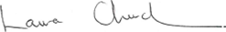

(Laura Church – Chief Executive, Bedford Borough Council)
Signature for Bedfordshire, Luton, and Milton Keynes Integrated Care Board.

(Felicity Cox - CEO Designate of the ICB for the Bedfordshire, Luton, and Milton Keynes Integrated Care Board.
Signature for Bedfordshire Police

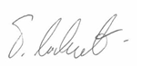

(Trevor Rodenhurst – Chief Constable, Bedfordshire Constabulary)
Date:

